Stage 3 Physics:
Electricity and Magnetism Student workbook

Name: TEACHER’S GUIDE

Description:
This unit focuses on electricity and magnetism, including electrical circuits, and magnetic fields. Students apply the concepts of charge and energy transfer to situations involving current electricity, the motor effect and electromagnetic induction.

Contexts:
Student unit learning contexts for electricity and magnetism may include:
- electric toys
- power generation and distribution
- motors and generators.

Working in physics
Students are given opportunities to develop their skills related to investigating and communicating scientifically. They plan and conduct investigations to obtain valid and reliable results and are prepared to justify their findings. Their problem-solving techniques include combinations of concepts and principles. They consider the level of absolute and percentage uncertainty in experimental measurements. This includes the use of error bars when displaying data graphically.

Plan For Unit.
This workbook will give you an outline of the content to be covered and the related text pages. It is not intended to be used alone but in conjunction with your text and teacher. It is expected that you will follow the workbook and read the related text, experiments and investigations before the lesson. It will be assumed that you have read the text and have some introductory knowledge of the work to be covered each lesson; failure to do so may affect your progress in class. Your teacher will then teach you the concepts and show you how to do the examples in the workbook thus ensuring you have exemplars when completing additional questions from the workbook and texts. Your teacher also has all the worked answers to the additional questions in this workbook and you must check your answers when you complete the questions.

In addition to the work set for homework, it is essential that you set up a study plan and regularly review the work covered. This plan should be set up from day one. Regular reviewing not only makes study easy, it ensures good grades.

Term 1
Wk | Content | Text Reference | Exploring Physics |  | Assessment
Wk | Content | Text Reference | Problem Sets | Experiments & Investigations | Assessment
9 | Week 9 – Lose Friday – Easter then into Holiday  Electricity and magnetism  - explain the attraction and repulsion effects for magnets, the behaviour of freely suspended magnets and magnetic compasses, and describe the nature of the Earth's magnetic field  - describe, using diagrams, the magnetic field in various magnetic configurations  - explain that magnetic fields are associated with moving charges, and draw the field due to a current flowing through a long straight wire, a short coil and a solenoid | Pg. 94-97  Pg. 98-103  Pg. 99-102 | Set 6:  Magnetic Fields and Forces | Expt. 6.1  Expt: 6.2  (Demo)  Optional  Expt: 6.3  Expt: 6.4 | Task 7: Test Motion and forces in a gravitational field

Term 2
Wk | Content | Text Reference | Exploring Physics |  | Assessment
Wk | Content | Text Reference | Problem Sets | Experiments & Investigations | Assessment
1 | - distinguish between direct and alternating currents and potentials, and apply Ohm’s law and the characteristics of series and parallel circuits—this will include applying the relationships:, 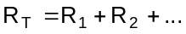 and 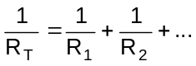  - describe and apply the concept of force on a current carrying conductor in a magnetic field, and describe the factors which affect the force on a current-carrying conductor in a magnetic field—this will include applying the relationship: 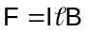 for perpendicular cases  - explain the torque produced by the force on a rectangular coil carrying a current in a magnetic field—this will include applying the relationships: 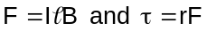 for perpendicular cases | CD. Pg. 446-466  Pg. 104-117  Pg. 111- 114 |  | Invest: 6.7  (Home invest. but students need a bar magnet).  Invest: 6.6 or 6.8
2 | - describe and apply the concepts of magnetic flux and magnetic induction—this will include applying the relationships: 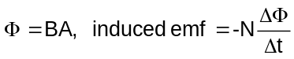 | Pg. 120-123 |  | Expt. 7.1  Expt. 7.2
3-4 | - describe the production of an induced emf by the relative motion of a straight conductor in a magnetic field—this will include applying the relationship: for perpendicular cases.  - interpret and explain situations involving induced emf, such as the AC generator, and Lenz’s law applications  - explain using electric fields the connection between electrical work, charge and potential difference—this will include applying the relationships of electrical work and power: 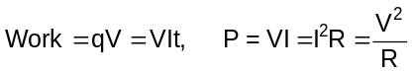  - explain and apply the principle of the transformer—this will include applying the relationship: 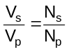  - explain why electrical energy is transmitted as AC at very high voltages, and describe and explain the impact on everyday life of electrical power generation and transmission—this will include applying the relationships: 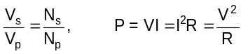. | Pg. 124-131  Pg. 132-139  Pg. 139-143  Pg. 144-150 | Set 7: Magnetic Induction  Set 8:  Electrical Energy and Power | Expt: 8.1  (demo)  Expt: 8.2  Expt: 8.3  Optional:  Invest: 8.5 to 8.7 home research assignments | Task 9: Test Electricity and Magnetism  Task 1: Practical Examination 3A
5 | Revision week
6 | SEMESTER 1 EXAMS |  |  |  | Task 11: Examination

Assessment outline: Stage 3 PHYSICS
Outcome 01: Investigating and Communicating in Physics;
Outcome 02: Energy;
Outcome 03: Forces and Fields

Assessment type | Assessment type weightings | Tasks | Content | Outcomes coverage |  |  | Weighting  %
 |  |  |  | O1 | O2 | O3 | 3A | 3B | Total
Experiments and investigations  (20-40%) | 21% | Task 1: Practical exam (3A) | Practical exam on 3A experiments and investigations |  |  |  | 5 |  | 5
Experiments and investigations  (20-40%) | 21% | Task 2: Research topic | Validation activity on student research (written report) |  |  |  |  | 3 | 3
Experiments and investigations  (20-40%) | 21% | Task 3: Extended Investigation | Extended investigation |  |  |  | 4 | 4 | 8
Experiments and investigations  (20-40%) | 21% | Task 4: Practical exam (3B) | Practical exam on 3B experiments and investigations |  |  |  |  | 5 | 5
Tests and Examinations  (60-80%) | 79% | Task 5:Validation tests on Assignments, Problem Sets and Homework | Accumulation of validation tests on Assignments, Problem Sets and homework |  |  |  | 2 | 2 | 4
Tests and Examinations  (60-80%) | 79% | Task 6: Test Projectile Motion | Test on projectile motion |  |  |  | 3 |  | 3
Tests and Examinations  (60-80%) | 79% | Task 7: Test Motion and forces in a gravitational field | Test on Motion and forces in gravitation al field |  |  |  | 4 |  | 4
Tests and Examinations  (60-80%) | 79% | Task 8: Test Particles, waves and quanta | Test on Particles, waves and quanta unit |  |  |  | 6 |  | 6
Tests and Examinations  (60-80%) | 79% | Task 9: Test electricity and magnetism | Test on Electricity and Magnetism unit |  |  |  |  | 6 | 6
Tests and Examinations  (60-80%) | 79% | Task 10: Test Motion and Forces in Electric and Magnetic Field | Test on Motion and Forces in Electric and Magnetic Field unit |  |  |  |  | 6 | 6
Tests and Examinations  (60-80%) | 79% | Task 11: Semester One Examination | Examination on 3A |  |  |  | 20 |  | 20
Tests and Examinations  (60-80%) | 79% | Task 12:Stage 3 Examination (includes 20% of 3A) | Examination on Stage 3 work |  |  |  | 5 | 25 | 30
TOTALS |  |  |  |  |  |  | 50 | 50 | 100

Outcomes 1 and 2
- explain the attraction and repulsion effects for magnets, the behaviour of freely suspended magnets and magnetic compasses, and describe the nature of the Earth’s magnetic field
- describe, using diagrams, the magnetic field in various magnetic configurations

MAGNETISM AND MAGNETIC FIELDS

Information on Magnets:

- A Magnet is a material that align itself naturally in a north-south direction when freely suspended
- Have two poles, North and South.
- Direction of field is direction the NORTH POLE of a compass points when placed in the field.
- Repels or attracts other magnets – like repel, unlike attract
- Attracts other magnetic material (iron, cobalt, nickel)
- Magnetism due to tiny magnetic regions (called domains) each with their own overall magnetic direction. When domains align, material becomes magnetised. Magnetic materials are those in which domains are easy to align.
- When domains not aligned, miniature magnets regions cancel each other out

QUESTION:
What effect does heating and hitting a magnet have on the property of magnetism and why is this so?
Both of these processes disrupt the domains and they are no longer aligned.
Hitting knocks them out of alignment.
Heating increases the kinetic energy of the particles and disrupts the alignment of domains.

Introduction to Magnetic Fields
- A magnetic field is defined as the area surrounding a magnet where a magnetic material (e.g. iron, nickel, cobalt) experiences a magnetic force of attraction.
- Magnets can come in many shapes, most common are Bar magnets and Horseshoe magnets.
Your teacher will show you how to draw the field around a bar and horseshoe magnet.
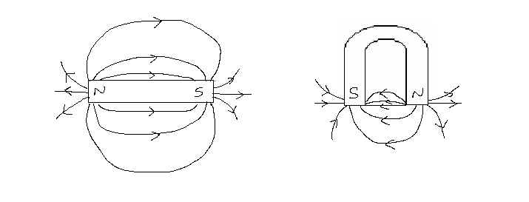

- Magnetic flux lines indicate the strength of the field. If the lines are concentrated (close together), the field is stronger.
- Lines do not actually exist. They show general shape and intensity of the field.
- Lines never touch or cross.

Outcome 3 and 4:
Explain the attraction and repulsion effects for magnets, the behaviour of freely suspended magnets and magnetic compasses, and describe the nature of the Earth’s magnetic field.
Describe, using diagrams, the magnetic field in various magnetic configurations

More on Magnetic Fields

- Definition – an area around magnet that will influence magnetic materials – they experience a force i.e. a force field.
- Field lines sometimes called “lines of force” or “magnetic flux lines” – closer together, stronger the force (remember, lines must never cross)
- Symbols and units for magnetic filed: Field strength or magnetic flux density – B; Unit - Tesla, T
- Direction of magnetic field always away from north towards the south (copy teacher diagram)

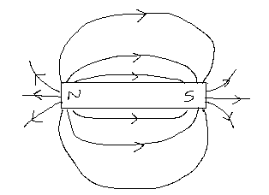

- Strength of force weakens as you move away.
- As force can move particles, you can get energy from the field hence field does work
- Diagrams of magnetic fields on freely suspended magnets (copy teacher diagram)

Two unlike poles Two like poles
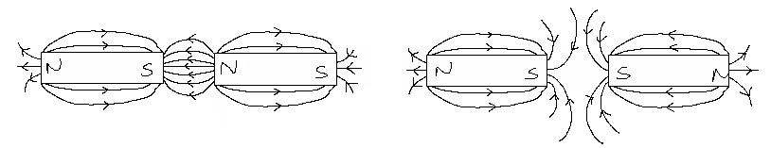
Magnetic fields exist more readily in magnetic materials, they have a high ‘permeability’ (property of a material to alter a magnetic field in which it is placed, or a measure of this property). An example is an iron ring between two magnets. (What would happen if the ring was aluminium?)

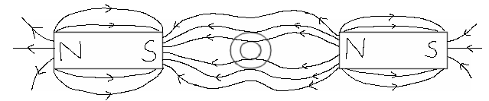

Iron washer distorts the field, i.e. the flux lines are ‘attracted’ to the iron

Strength of Field:

Number of flux lines per unit area. The area is at right angles to the field and the field strength may be calculated by the following formula (covered in more depth later in workbook):

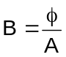 where B = magnetic field strength/intensity (tesla, T)
φ = amount of flux (weber, Wb)
A = the area perpendicular to the field (m²)

Magnetic Field of the Earth
- Field is called the magnetosphere and exists as though the Earth has a large bar magnet inside.
- Field not as simple as shown below as atmospheric conditions and solar winds from sun affect field.
- Earth’s magnetic field has been changing constantly both in strength and position.
Earth’s Magnetic Field
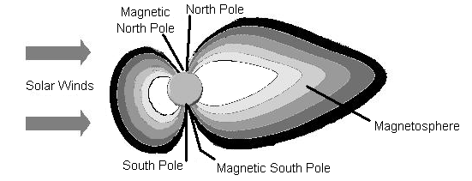

- It is believed that the Earth’s Magnetic Field is generated by
  - charged particles circulating in the Earth’s liquid outer core
  - forces caused by its rotation
- An electric current is generated which causes a magnetic field.
- The Earth’s Magnetic Field is needed to protect the Earth by deflecting high-energy particles from the Sun which would harm or destroy life on Earth.

- The magnetic poles of the earth do not correspond with the geographic poles of its axis.
- The position of the magnetic poles is not constant and shows an appreciable change from year to year.
- Note: As north Pole of compass must be attracted to Earth’s South Pole, the Magnetic north pole is actually a SOUTH pole and the Magnetic south pole is actually a NORTH pole.

Angle of DIP
The magnetic field of the Earth is not parallel to the Earth’s surface. The angle between the Earth’s surface and the Earth’s magnetic field is known as the angle of DIP.

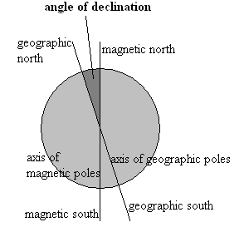
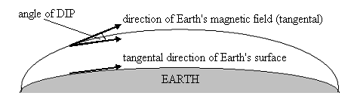

Angle of declination
Angle between the axis of the magnetic poles and the Earth’s geographic poles (north and south poles).

Problem Set 1:
Draw the magnetic field for each of the following cases.
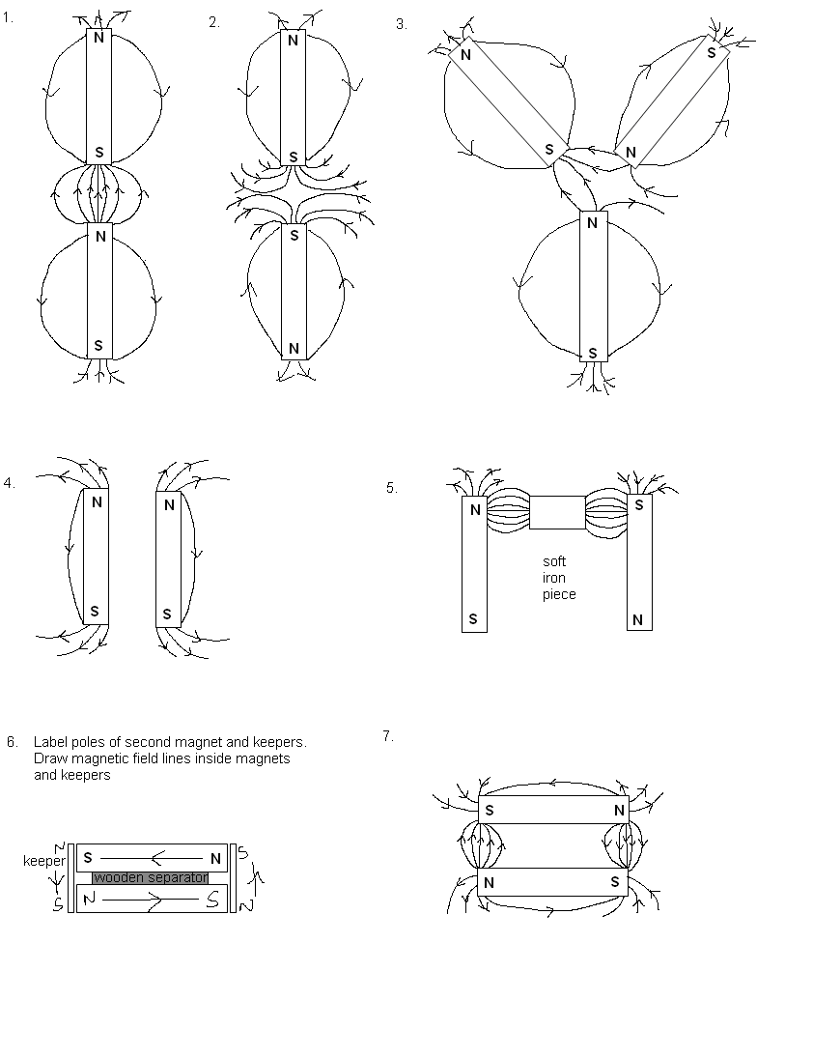

Exploring Physics
Experiment 6.1 force-distance-relationship for a bar magnet page 64

Outcome 4:
distinguish between direct and alternating currents and potentials, and apply Ohm’s law and the characteristics of series and parallel circuits—this will include applying the relationships:, and

NOTE:
The concepts in this outcome were fully covered in Stage 2 Physics so will only be summarised here. If you need more information on this section of work read your text book and study guide and discuss with your teacher.

ELECTRIC CURRENT
When charges move, they form an electric current. We can say that current is the rate of transfer of charge or the rate of flow of electrons or the rate of flow of charge.

The unit of electric current is the ampere (A). If one coulomb of electric charge passes any one point in one second, it is said to form one ampere (A) of current.

Mathematically, we can express this as 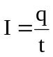 where q = charge in coulombs (C)
I = current in amperes (A)
t = time in seconds (s)

Conventional Current And Electron Current

Prior to 1897 when Thomson discovered electrons, scientists believed that electricity was a flow of ‘electric fluid’ which moved from a positive potential to a negative potential (flow of positive charge). By the time they realized that negative electrons flowed in the opposite direction, the idea of a positive flow of charge was too firmly built into the theory of electricity. As current is the rate of transfer of charge, we now call the flow of positive charge conventional current and the actual flow of electrons, electron current.

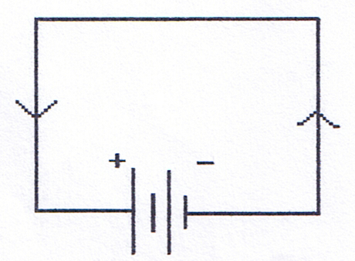
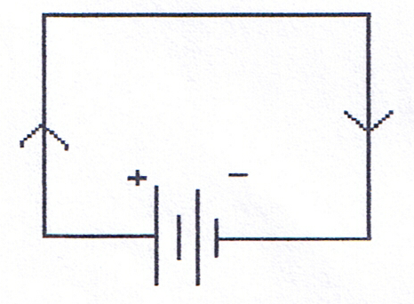

Conventional Current:  Defined as being in the direction of charge transfer. When we refer to the direction of current in a circuit we are referring to conventional current. |  | Electron Current:  Electrons flow from a region of higher potential to lower potential, in other words, from negative to positive. Electron current is used to describe the actual movement of electrons.

Direction Current And Alternating Current

In direct current, or DC circuits, the flow of electricity is only one way. The polarity of the potential difference stays constant, in other words, the positive terminal is always positive and the negative terminal always negative.

In alternating current, or AC circuits (studied next year), the polarity of the potential difference can change in a regular way, so that the charge first flows in one direction, then in the other. The Australian mains electricity supply is 240 V AC, changing polarity 50 times a second; that is a frequency of 50 Hertz.
ELECTRICAL RESISTANCE – OHM’S LAW

When a current flows in a circuit, there is a resistance to the flow that results in energy losses from the electric circuit. Materials that offer electrical resistance are called resistors. The ratio of the potential difference (sometimes called voltage and measured in volts - V) to the current for a component is called the resistance and it is measured in ohms with the unit being the Greek letter Ω (pronounced ‘omega’). A resistance (R) of 1 ohm is experienced if there is a potential difference (V) of 1 volt per 1 ampere of current (I) flowing, therefore:

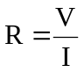 Where: R = resistance in ohms (Ω)
V = potential difference in volts (V)
I = current in Amps (A)

Some of the factors that can affect electrical resistance are:
- size of potential difference across the ends of the wire
- length of the wire
- cross-sectional area of the wire
- temperature of the wire
- the material from which the wire is made (resistivity)

Georg Simon Ohm was the first scientist to study the relationship between potential difference and current. Any conductor for which the potential difference vs current graph is a straight line is called an ohmic conductor the relationship is said to be directly proportional starting at 0,0 (see graph (b) below).

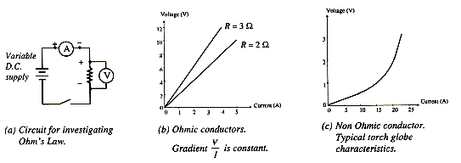
The resistance of some conductors can be affected by light or temperature and a plot of voltage vs current for such resistors produces a curved line (see graph (c) below). These phenomena give rise to some useful devices such as Light Dependent Resistors (LDR) which are used in security lights and Thermistors used in fire alarms and fire sprinkler systems. These resistors are called non-ohmic conductors as the relationship between potential difference and current is not directly proportional and a curved line is obtained when graphing.

Questions:
- What is the potential difference across a 20.0 Ω resistor which is carrying a 4.00 A current?

V = IR
V = 4 x 20
V = 80 V

- A current of 1.00 x 10² mA flows through a resistor of 5.00 x 10⁶ Ω. Calculate the potential difference across the resistor.

V = IR
= 0.1 x 5 x 10⁶
V = 500000
V = 5.00 x 10⁵ V

ELECTRICAL COMPONENTS
Electrical components can be divided into four main areas:
  - conductors e.g. wires
  - resistors e.g. lights, electrical appliances
  - sources of potential e.g. batteries, chemical cells, power packs
  - switches to control the flow of electrons.

Electrical circuits can often be very complex so to simplify things, circuit diagrams are used with circuit symbols for the components.
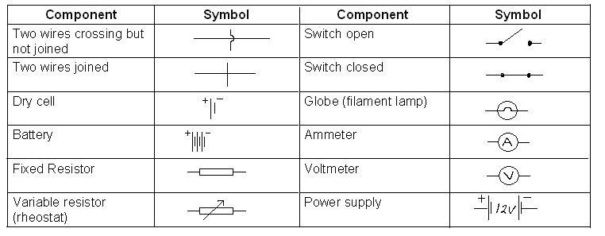
The Basic Circuit:
The basic circuit has a power source, switch, resistor (globe) and leads.

Besides the basic circuit, there are three main types of circuits:

Series – in which all parts of the circuit are connected in a continuous circle (although for easy reading, we usually draw a rectangle shape). These are simple circuits as there is only one path for the current. In a series circuit, there is only one path for the current as shown below. Cheap Christmas tree lights are a good example of this type of circuit or a switch for lights.
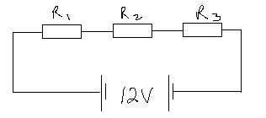

Parallel – parts of circuit connected in parallel so that each part has its own path for the current. These circuits are set up so that each electrical device has its own path for the current as shown below. The sum of the currents in the different parts of a parallel circuit is equal to the total current. House lights are set up in parallel so that if one goes out the rest stay on.

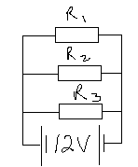
Complex – combination of series and parallel connections. Most electrical devices are complex circuits.

Resistance, Current and PD in Circuits – The Theory

- The Basics

- Electrons flow around the circuit from the energy source (power pack) back to the energy source – the rate of flow of electrons (or charge) is called current (symbol I) and is measured in amperes or Amps (symbol A).
- Any part of the circuit that tries to slow the movement of the electrons (current) is called a resistor. This slowing is called resistance (symbol R) and is measured in ohms (symbol Ω).
- The electric potential difference (symbol V) can be described as the work done per unit charge as a charge is moved between two points in an electric field. That is, V = W ÷ q, which we have already studied on page 19 of this workbook.

Another way of looking at potential difference that can help in understanding the mathematical electrical circuits is that potential difference can be thought of as the energy given to the electrons by the energy source (power pack) that can be used to run electrical devices such as globes. The energy source is called an emf or electromotive force and although its units are volts, it is very different from potential difference (Year 12 work).

- Applying The Basics
- Electrons given energy by power pack to create a large charge difference (potential difference).
- Electrons move around circuit at a certain rate (current)
- When electrons come to a resistor (electrical device) they use energy (potential difference) to overcome resistance – that is, they do work.
- Electrons then return to power pack for more energy.

NOTE: Consider the globes to be ohmic resistors for this page only.

C. Series Circuits:
You now know that in a series circuit, there is only one path for the current. Cheap Christmas tree lights are a good example of this type of circuit and this type of circuit will not work if one of the parts (e.g. a globe) is broken as the path for the electrons to flow is broken. Remember that the globes resist the flow of electrons and cause electrons to bunch up (potential difference) so as more globes (resistors) are added, they all get dimmer and dimmer. This also results in less current flowing through the circuit (rate of flow of electrons) as there is more resistance as each globe is added to the circuit so harder for electrons to get around circuit.

D. Parallel Circuits
In a parallel circuit there is more than one path for the electrons to flow so if one part of the circuit is broken e.g. by a blown globe, the rest of the globes will stay on as the electrons still have a path to flow through. The sum of the currents in the different parts of a parallel circuit is equal to the total current of the circuit. The electrons carry the energy (potential difference) from the power pack and are able to go down different paths and light all the globes to the same brightness (each gets the same amount of current flow) as long as the globes have the same resistance. To keep globes at the same brightness, it means that more electrons are needed so the current required increases (increased flow to carry more energy) as more globes are added in parallel. This is also due to the decrease in resistance as more paths mean more electrons to flow.

Mathematical relationship
Ohm’s Law: V = IR
Series circuits: current same throughout series section: I_{T} = I₁ = I₂
potential difference is added: V_{T} = V₁ + V₂
resistance is added R_{T} = R₁ + R₂
Parallel circuits: potential difference same throughout parallel section: V_{T} = V₁ = V₂
current is added I_{T} = I₁ + I₂
inverse of resistance is added 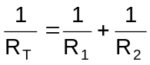
MATHEMATICS OF CIRCUITS:
Your teacher will work through the following problems with you.

Simple Circuit:
- A resistor is placed in a simple circuit with a 12.0 V potential difference. If the current through the circuit is 0.24 A, what is the value of the resistor.
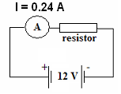

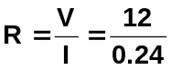

R = 50 Ω

Series Circuits:
- Two resistors of equal value are placed in the circuit. If the current is 0.12 A, what is the value of each resistor?
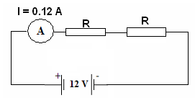
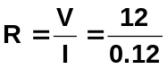
R_{T} = 100

as R_{T} = R₁ + R₂ and both the resistors are the
same value,
R₁ = R₂ = 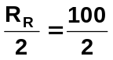
= 50 Ω each

- Two resistors are placed in series. The ammeter reads 0.080 A. If R1 is twice the resistance of R2, what is the resistance of each resistor.
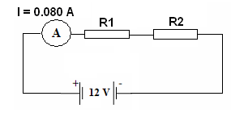

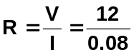
R_{T} = 150

R_{T} = 2R₂ + R₂
150 = 3R₂
R₂ = 50 Ω

R₁ = 2 x 50
R₁ = 100 Ω

Parallel Circuits
- Two resistors of equal value are placed in a parallel circuit. A current of 0.480 A flows through A3. What is the value of each resistor?

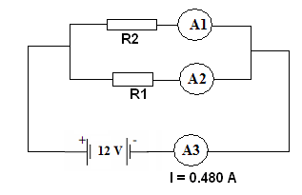
As each resistor is of equal value, half the total current runs through each ie. 0.24 A

Find R₁
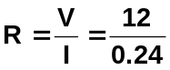
R₁ = 50 Ω

as both are equal, each must be 50 Ω

Combined Circuits
- The two resistors labelled R are identical. Using the information given in the diagram below, find the value of one of these resistors.
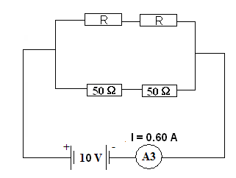

R_{T} for bottom two resistors:

R_{T} = 50 + 50 = 100 Ω

Current through bottom branch

V = 10 V (in parallel)
R = 100 Ω

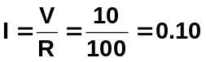 A

Current in top branch = 0.6 – 0.1
= 0.5 A

R_{T} to branch:

V = 10 V
I = 0.5 A
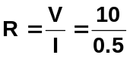
R = 20 Ω

as both resistors are equal, each must be 10 Ω

You should do the questions in your text and study guide for further practice of these concepts.

Outcome 5:
Describe and apply the concept of force on a current carrying conductor in a magnetic field, and describe the factors which affect the force on a current-carrying conductor in a magnetic field—this will include applying the relationship: for perpendicular cases.

Electromagnetism – Magnetism from Electric Currents:
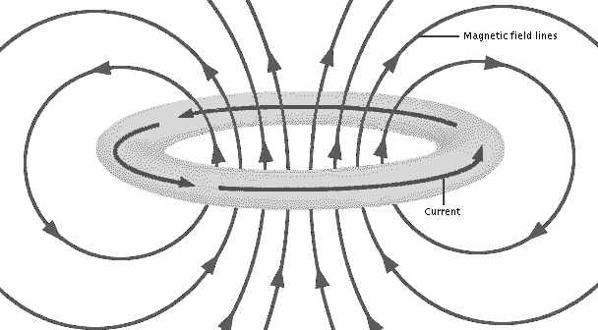
Magnetic Fields and Currents
Hans Christian Oersted predicted in 1813 that a connection would be found between electricity and magnetism. In 1819 he placed a compass near a current-carrying wire and observed that the compass needle was deflected. This discovery demonstrated that electric currents produce magnetic fields. As shown here, the magnetic field lines circle around the current-carrying wire.

Direction of the field or current can be determined by the Right Hand Grip Rule:
If a straight conductor is held in the right hand with thumb pointing in the direction of conventional current (positive to negative) the curled fingers show direction of circulars field.

Direction of current can be drawn as follow (copy teacher diagram):
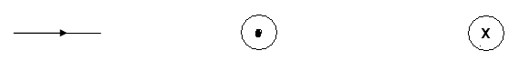
Arrow shows direction parallel to page |  | Shows current coming out of page, arrow towards you |  | Shows current going into page, arrow away from you.

Your teacher will help you determine the direction of the field in the following straight line conductors.

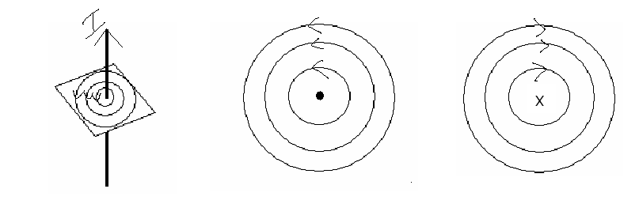

Applications of Electromagnetic Principles:
Electromagnets have had a significant technological impact and have lead to numerous applications. For example, electric motors, stereos, radios, T.V., electrical meters, oscilloscopes, computers, dynamos, generators, alternators and of course, the large electromagnets used for cleaning up scrap yards and industry.

Fields Around A Coiled Wire

Firstly, why coil the wire?
Straight wire produces a circular magnetic field that quickly weakens as you move away from the wire - not a very useful field for practical purposes.

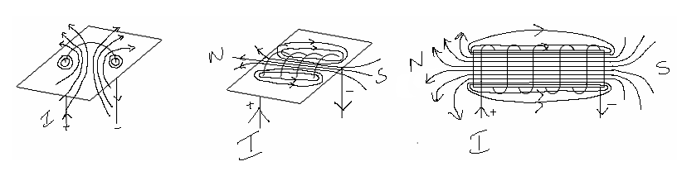
In a single loop, the magnetic field is magnified in the centre of the loop but is still not strong enough. Your teacher will illustrate the fields in the following situations.

By twisting the wire into a large number of helical coils (spirals) a magnetic field of a permanent magnet can be simulated. This electromagnet (or solenoid) is strong enough to replace permanent magnets and as the number of coils is increased, a very powerful magnet can be created that has the advantage of being able to be switched off.

To determine the north and south ends of a solenoid,
a. “stand” at one end e.g. the left.
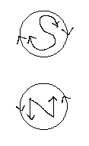
b. determine if the direction of current is clockwise or anti-clockwise

c. clockwise - south

anti-clockwise - north

d. Alternatively, use the Right Hand Grip Rule for Solenoids (conventional current).
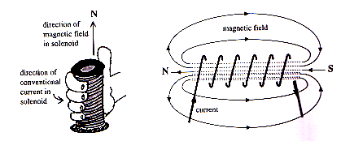

Exploring Physics
Experiment 6.2: Force on a conductor in a magnetic field page 65

CURRENT, FIELD AND FORCE
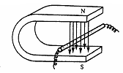
If a current-carrying wire is placed in a magnetic field as shown below, it can easily be demonstrated that a force is exerted on the wire. This force causes the wire to move either into or out of the horseshow magnet, depending on the direction of the current in the wire.

The motion of the wire is called the ‘motor effect’.

Your teacher will show you a demonstration electric motor. What do you think produced the force that caused the coil to turn?
Interaction of magnetic field from permanent magnet and electric current in coil.
Motor Effect
Motor Principle:

coil + magnet + electricity = movement

An electric motor works as follows:
- A coil of wire is placed between two permanent magnets as shown above.
- Electricity is passed through the wires
- The electricity in the wires causes a magnetic field to form
- The magnetic field of the permanent magnets interacts with the magnetic field of the coil
- The two magnetic fields cause the coil to turn as shown below. If the coil is attached to a rod, then the rod will also turn and this can be used to run something, for example a toy car.
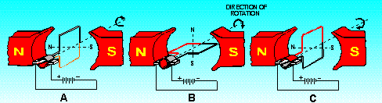

Right Hand Slap Rule
The direction that the wire moves can be found using the Right Hand Slap Rule
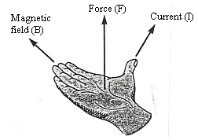
- Thumb is current direction (conventional)
- Fingers point in direction of field (North to South)
- Palm points in direction of force.

In your own words, fully explain why a force is created?
Current in coil (moving electrons) creates a magnetic field that interacts with the magnetic field from the magnet around the coil. The interaction creates a net force and this
force acts on the coil causing it to rotate.

Describing direction
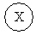


top of bottom of right left into page out of page
page page

For each of the following situations draw in the direction of the force.

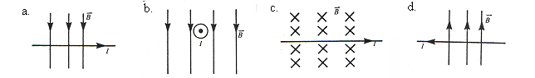
into page right top of page into page

Questions on work covered so far.

1. Draw in the following fields and find the direction of the field.

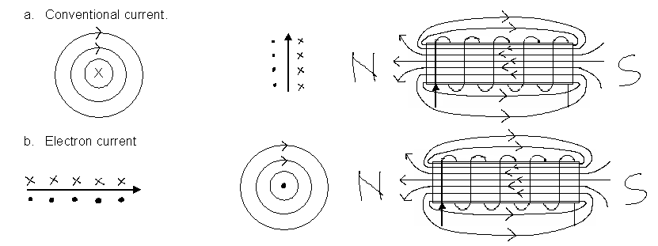
  - Find the direction of the third component (I, B or F) assuming conventional current.

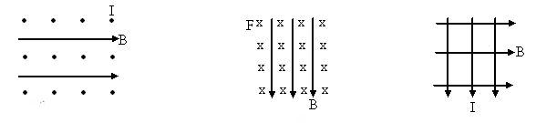
F top of page I right F out of page

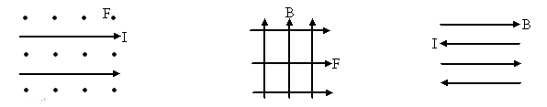
B top of page I into page no force as lines
parallel

CALCULATING THE STRENGTH OF THE FORCE.

Three factors are important in calculating the force on the wire. What do you think they are?
- size of current
- strength of magnetic field
- length of conductor in magnetic field
Logically, it should be realized that the force would be affected by the strength of the magnetic field, the size of the current, and how much wire is actually in the magnetic field. In fact,

F = BIl where F = force in newtons (N)
I = current in amperes (A)
B = strength of magnetic flux density in teslas (T)
= length of conductor in magnetic field in metres (m)

Example:
An electric motor in a hair dryer needs a current of 10.0 A to operate. If the side of the armature between poles of the magnet is 120 mm long, what force acts on each wire around the armature when it is perpendicular to the magnetic field of strength 2.00 T.

F = ? F = BIl
B = 2.0 T = 2.0 x 10 x 0.12
I = 10 A F = 2.40 N
l = 0.12 m

NOTE:
- B is the magnetic field from the magnets as we are only interested in the force on the conductor, and not the force on the magnets due to the field created around a moving charge.
- In WACE Examination only for perpendicular cases.

Outcome 7:
Describe and apply the concepts of magnetic flux and magnetic induction—this will include applying the relationships: 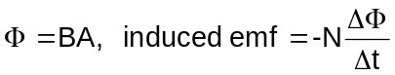

MAGNETIC FLUX and MAGNETIC FLUX DENSITY

To fully describe a magnetic field at a point, both a direction and a magnitude (or strength) must be given. This is known as the magnetic flux density, represented by the letter B and has the unit tesla (T). It is often more useful to know the total effect of a magnetic field, known as the magnetic flux, φ, the unit of magnetic flux is the weber (Wb).

φ = BA where φ = magnetic flux (Wb)
B = magnetic flux density (T)
A = area (m²)

Magnetic Flux Density - field at a point needing both direction and magnitude, also called magnetic field strength.

Magnetic Flux - total field effect so flux density multiplied by area

Magnetic Flux Density
- Often called Magnetic Field Strength
- Symbol is B
- Has the units of Teslas, T.
- Strength of magnetic field in which wire or coil moves.
- For permanent magnets, value doesn’t change.
- For electromagnets, value can be changed by changing size of current in wires surrounding soft iron bar.

Magnetic Flux
- Symbol φ
- Actual formula is φ = BA cos θ
- Where B is component of magnetic field perpendicular to the face of the coil. When face is perpendicular to the field, θ = 90⁰ so φ = BA (will only get 90⁰ in WACE examination)
- Looking at coil down from the top:

Coil parallel to Coil at 45⁰ to Coil at 90⁰
Field, φ = zero field, φ = BA cos 45 field, φ = BA

- This now explain the graph of magnetic flux, φ versus time.
For a coil starting as shown and rotating clockwise 360⁰
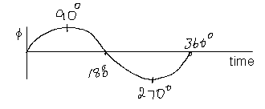
NOTE:
Maximum flux over ¼ of a turn

Example:
What is the total magnetic flux passing through an area of 2.50 x 10⁻⁴ m² if the magnetic flux density is 5.00 x 10⁻⁴ T?

A = 2.5 x 10⁻⁴ m² φ = BA
B = 5.0 x 10⁻⁴ T = 5 x 10⁻⁴ x 2.5 x 10⁻⁴
φ = 1.2 x 10⁻⁷ Wb

Example: (NOTE: While your outcome is for perpendicular cases, other cases do exist as shown in the example below.)

A coil in an electric motor is at an angle of 40⁰ to the horizontal. If the field strength is 5.00 x 10⁻⁴ T, and the coil has an area of 4.00 x 10⁻³ m², what is the magnetic flux passing through the coil?
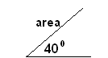
Area φ = BA
A = 4 x 10⁻³ sin 40 = 5 x 10⁻⁴ x 2.6 x 10⁻³
= 2.6 x 10⁻³ m² φ = 1.3 x 10⁻⁶ Wb
B = 5 x 10⁻⁴ T

Do the following questions (answers are shown but you need to show work how to get the answer):

- Find the total flux through an area of 0.060 m² at right angles to a uniform field of magnetic flux density 1.75 T. (0.105 Wb)

A = 0.06 m² φ = BA
B = 1.75 T = 0.06 x 1.75
= 0.105 Wb

- If 6.089 x 10⁻⁴ Wb threads an area of 165 mm², what is the magnetic flux density?
(3.69 T)

φ = 6.089 x 10⁻⁴ Wb 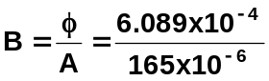
A = 165 x 10⁻⁶ m² B = 3.69 T

- At a certain place on the earth’s surface, the horizontal component of the earth’s magnetic field is 4.50 X 10⁻⁵ T. A wire oriented at right angles to this horizontal component is moving vertically so it cuts the field at right angles with a speed of 25.0 ms⁻¹. If the wire is 12.0 m long, what is the magnetic flux cut per second?
(1.35 x 10⁻² Wb s⁻¹)

B = 4.5 x 10⁻⁵ T A = 25 x 12 φ = BA
v = 25 ms⁻¹ = 300 m each sec = 4.5 x 10⁻⁵ x 300
l = 12 m = 0.0135 Wb s⁻¹

φ = 1.35 x 10⁻² Wb s⁻¹

- The flux density in a cylindrical iron rod of diameter 2.00 cm is 2.10 T. What is the total magnetic flux inside the rod? (6.60 x 10⁻⁴ Wb)

A = πr² φ = BA
= π x (1.0 x 10⁻²)² = 2.1 x 3.1416 x 10⁻²
= 3.1416 x 10⁻⁴ m² = 6.60 x 10⁻⁴ Wb

Possible Demo Experiment:: Current Balance showing mg = BIl (Old STAWA Laboratory Text)

Outcome 6:
Explain the torque produced by the force on a rectangular coil carrying a current in a magnetic field—this will include applying the relationships: for perpendicular cases

THE D.C. ELECTRIC MOTOR

The diagram below shows a simple D.C. motor
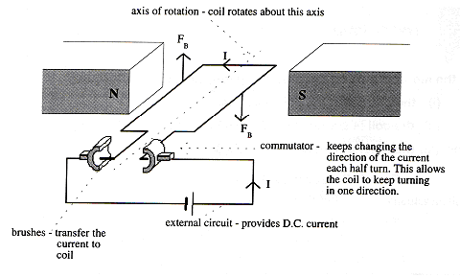

The force on each side of the coil perpendicular to the field is determined by:

F = nBIl where F = force on each side of the coil (N)
n = the number of coils
I = the current flowing in the coil (A)
l = length of conductor perpendicular to magnetic field (m)
B = the magnetic field intensity.

The turning effect or torque can be determined as follows:

τ = 2 r⊥ F where τ = torque (Nm)
F = force on each side of the coil (N)
r⊥ = perpendicular distance from axis to rotation to edge of coil (m)

Example:
A motor with a square coil of sides 5.00 cm and 200 turns, has a current of 2.00 A passing through it. If the magnetic field of the magnets is 0.450 T determine the torque of the motor.

F = nBI l
= 200 x 0.45 x 2 x 0.05
F = 9.00 N

τ = 2 x 0.025 x 9.0
= 0.45 Nm

To improve the turning effect of a motor
- Use stronger magnets
- Use more coils
- Have a larger current
- Use a soft iron core in the coil (increases overall magnetic field of coil)

Fields around coils in a motor
When a coil is placed within a magnetic field and a current allowed to run through the coil, the interaction of the two fields causes a force to be produced that produces movement. The force is a maximum when the coil is parallel to the magnetic field.

Where the magnetic field of the permanent magnet is in the same direction as the magnetic field produced in the current carrying coil, then the field strength is increased and a force is applied to the wire that tries to move it away from the higher field strength.

Your teacher will show you the fields around the coils between the magnets when the coil is in different positions.
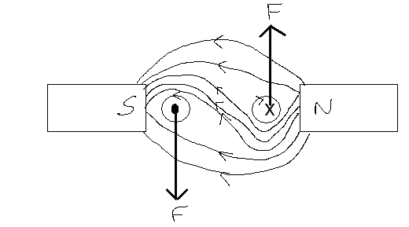
When the coil is perpendicular to the field, the force still tries to move it perpendicular to the magnetic field, but the axle of the coil prevent movement.

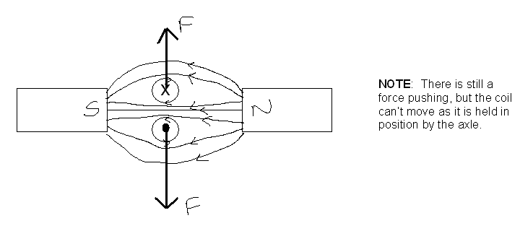

Exploring Physics
Experiment 6.4: Magnetic field intensity between the poles of a horseshoe magnet page 69
Set 6: Magnetic Fields and Forces page 71.
Outcome 8:
Describe the production of an induced emf by the relative motion of a straight conductor in a magnetic field – this will include applying the relationship: induced emf = Blv for perpendicular cases.

FARADAY’ S DISCOVERY

Faraday found that when a wire is moved through a magnetic field, a current is generated in the wire. If the wire moves up through the field, the current moves in one direction, if moved down, the current moves in the other direction.

For a current to be produced either the conductor can move through the field or the field can move past a conductor. In both cases, it is the motion between wire and magnetic field that produces the current. Whenever the magnetic flex lines are cut by a conductor which is part of a closed loop, a current is induced in the loop. This is called electromagnetic induction.

When the wire moves through the field the energy of the electrons is increased. Their electrical potential is raised. The difference in potential is the induced emf (electro-motive force). The emf, measured in volts, depends on the magnetic flux density (B) the length of the wire in the field () and the velocity of the wire in the field (v). If B, l and v are mutually perpendicular,

emf = Bv

Example:
What emf is induced between the ends of a 25.0 cm long rod that is moving perpendicular to a magnetic field of 350 mT at 5.00 ms⁻¹?

emf = Blv
= 350 x 10⁻³ x 25 x 10⁻² x 5
emf = 0.44 V

Faraday’s Law of induction states that the magnitude of the induced emf in a circuit is directly proportional to the rate at which the flux through the circuit (in the coil) is changing, this changing field produces the induced emf
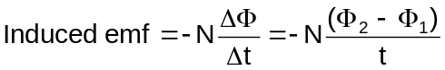
The sign is negative due to opposite
direction of induced current.

Where: N = number of turns of coil
(φ₂ - φ₁) = number of flux lines cut (also called flux linkage) in webers (Wb)
(always larger value minus smaller value)
t = time in seconds

Example:
A coil of 600 turns is threaded by a flux of 800 mWb. If the flux is then reduced to 200 mWb in 1.8 ms, what is the average emf induced in the coil?
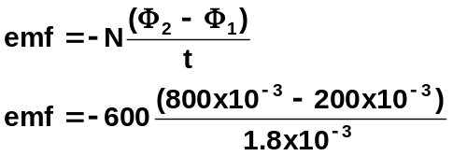

emf = -2.00 x 10⁵ V

Remember that the negative sign indicates the emf in opposite direction to that which created it. Can be called a ‘back emf’ as opposes initial motion. This regulates speed of motor.

Exploring Physics
Experiment 7.1: Inducting an emf in a solenoid

Questions on Fields, forces and torque.

- Draw the field around the following, bar magnets with a current carrying wire between them. The magnets have opposite poles facing each other.
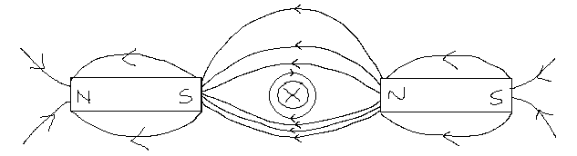

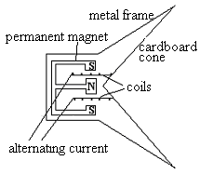
- The diagram below shows a speaker.

  - Why does the speaker use alternating current? Speaker needs to move in and out to produce sound. Alternating current results in changing direction of current so change in coil movement.

  - What happens when a current initially enters the coil? Current in coil produces field, field interacts with permanent magnet creating a force and coil moves either in or out

  - Explain, using the ideas above, how the speaker works.
Electrical signal from initial sound put into speaker. Magnetic field from current interacts with field from permanent magnetic. Changes in current changes magnetic field strength and direction, cone vibrates producing sound waves.

- 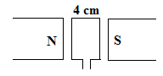A motor with a coil of 120 turns has a permanent magnet producing a magnetic field of 0.05 T. Using the diagram below, determine the force on one side of the motor if the lengths of the sides of the motor are 4 cm and 6 cm.

l = 0.06 x 120 = 7.2 m F = BI l
= 0.05 x 0.2 m 7.2
F = 0.072 N

- A square coil of wire of side length 3.5 cm is placed in a magnetic field of 0.6 T as shown below. If a current of 2.3 A runs through the coil and the coil have 250 turns,
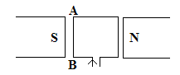

  - in which direction will the side AB move? out of page
  - what is the force on side AB?

F = BI l
= 0.6 x 2.3 x 8.75
F = 12.075
F = 12.1 N

  - what is the torque on the motor?

r⊥ = 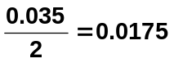 τ = 2Fr⊥
= 2 x 12.075 x 0.0175
τ = 0.423 Nm

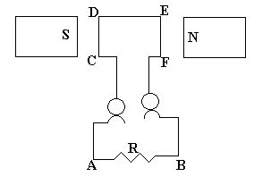
6. Look at the diagram of a motor below:

Side CD is moving into the page.
- Which way will the current flow through R?
A to B or B to A
- The potential difference is 3.40 V and the resistance 12 ohms, determine the minimum power to rotate the coil.

V = 3.4 V 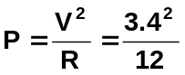
R = 12 Ω P = 0.92 W

P = VI
I = V / R
P = VV / R
P = V² / R

  - Calculate the torque on a square motor which has 500 turns, if the length of the sides between the 0.80T permanent magnetic field is 23.0 cm and the current in the motor is 2.1 A?

turns = 500 τ = Fr⊥
length = 0.23 = 2(BIl)
= 2 (0.8 x 2.1 x (500 x 0.23) x 0.115)
τ = 44.4 Nm

Outcome 9:
Interpret and explain situations involving induced emf, such as the AC generator, and Lenz’s law applications

Introducing Lenz’s Law
The direction of an induced current is such as to always oppose the change that is producing it.
When a magnet is moving into a coil, current is created in the coil, the current then creates a magnetic field which is in the opposite direction to the original magnetic field. (This makes sense because if they were in the same direction then they would continually reinforces each other ad infinitum thus obtaining unlimited energy for very limited expenditure.) This effect is known as Lenz’s Law and shows why Faraday’s equation is written with a negative sign:

NOTE: There are some excellent diagrams on page 71 of your WACE Study Guide. It is recommended that you look at these diagrams and do the questions that follow in your Study Guide.

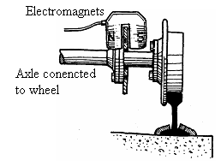
Applications Of Lenz’s Law

Magnetic brakes on trains. When the brakes are applied, there is a magnetic field generated between electromagnets. As each section of the disc passes between the poles of the magnets it experiences a changing magnetic field. An emf is induced producing a current in the disc which then produces a magnetic field that opposes the direction of the other field causing the disc to slow and slows the train.

Electric Generators
An electric generators is the opposite of an electric motor in that a coil of wire is manually turned between two permanent magnets creating an electric current.
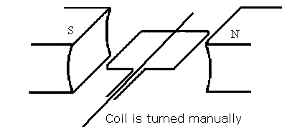
Generator Principle:
coil + magnet + movement = electricity

A generator works as follows:
- A coil of wire is placed between two permanent magnets as shown above.
- The coil is turned manually (often by running water)
- As the coil moves through the field of the magnets it generates electricity in the coil.

Commercial A.C. Generators have:

- Field magnets (stators)
- Many coils on armature
- Large fans for cooling
- Turbines ⇒ to enable armature to turn via external means (often steam).

In Collie, coal is burnt to boil water and produce steam. The steam is used to turn large turbines that turn large coils between magnets producing the electricity used in Bunbury.
THEORY BEHIND GENERATORS

This diagram shows a basic AC generator. Don’t forget to use left hand for generators
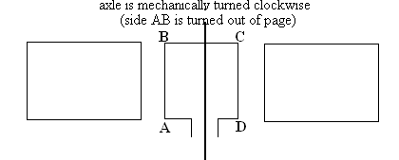

Permanent magnet

N S

Generators produce alternating current by the following process:

Firstly:
The coil is rotated clockwise (AB out of page) but by using Lenz’s Law, as AB moves upwards a downward magnetic force must be exerted on it to oppose this rotation. Using the motor principle, this downwards force will be exerted on conductor AB only if current is flowing from A to B as shown below. Similarly, the current in CD must flow from C to D.

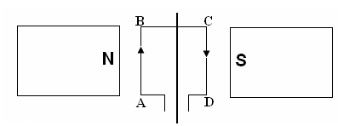
Side AB moves out of page Side CD moves into page
Magnetic Force exerted into page Magnetic Force exerted out of page
Magnetic Field to right of page Magnetic Field to right of page
Current induced from A to B Current induced from C to D

Secondly:
The coil is now turned 180⁰. Now the opposite occurs and the current runs from B to A and from D to C.
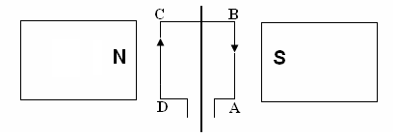
Side AB moves into page Side CD moves out of page
Magnetic Force exerted out of page Magnetic Force exerted into page
Magnetic Field to right of page Magnetic Field to right of page
Current induced from B to A Current induced from D to C

In other words, the current has reversed direction.

Thirdly:
This turning continues and produces an Alternating Current (AC).

CALCULATIONS INVOLVING GENERATORS

While you have already seen the formula involved, it is useful to revisit it with some additional information when completing problems involving emf.

Note:
- Formulae assume constant change in flux and hence we calculate the average emf. Formulae do not calculate maximum emf.
- Negative sign in formula relates to Lenz’s Law. Induced magnetic field surrounding the coil is opposite to the change producing the emf.
- Maximum emf occurs when coil is parallel to magnetic field and no emf is induced when coil is perpendicular to field (further explain in next two pages).
- Magnetic flux threading the coil changes from minimum when coil is parallel to field and maximum when coil is perpendicular to field (further explain in next two pages).
- Maximum change in flux and emf occurs each quarter of a turn.

Example:
An armature of a small AC generator is rotating at 2000 rpm. through a uniform magnetic field of 2.00 Tesla. If the armature has an area of 0.0055 m² and has 200 turns, find the average emf induced.

Zero flux threading coil maximum flux threading coil
i.e. BA = 2 x 0 i.e. BA = 2 x 0.0055
φ₁ = 0 Wb φ₂ = 0.011 Wb

average emf in ¼ turn so
2000 turns in 60 s
= 0.25 turns in x s emf = -N (φ₂ - φ₁)
t
x = 60 x 0.25 emf = -200 (0.011 – 0)
2000 0.0075
t = 0.0075 s emf = -293 V

Example for you to try:
A coil of wire has 50 turns and an area of 6.25 x 10⁻⁴ m². It is rotating steadily at 50.0 revolutions per second about an axis in the plane of the coil at right angles to a uniform field of flux density 0.500 T. What is the average emf induced in the coil?

turns = 50 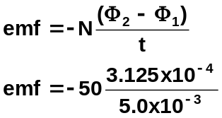
A = 6.25 x 10⁻⁴ m²
emf = 3.125
50 turns in 1 s
0.25 turn in x s

t = 5.0 x 10⁻³ s emf = 3.13 V

φ₂ = 0.500 x 6.25 x 10⁻⁴
= 3.125 x 10⁻⁴ Wb
φ₁ = 0 Wb

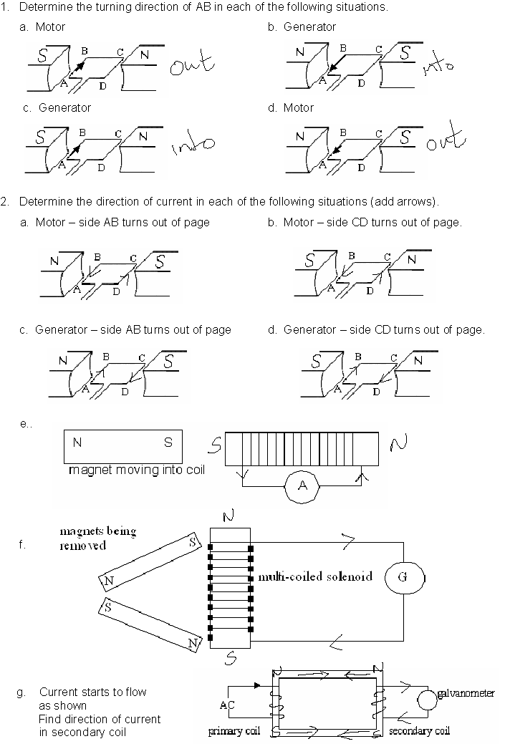
Review of DC Motors, Induced emf and AC Generators.
- Consider the following motor. AB = CD = 4 cm BC = 1.75 cm
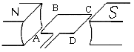B = 0.05 T I = 1.5 A

- In which direction does the coil turn? anticlockwise – AB into page

- Determine the force on: (i) AB F = BIl = 0.05 x 0.04 x 1.5 = 3.0 x 10⁻³ N into page
- BC no force
- CD 3.0 x 10⁻³ N out of page

- Calculate the torque of the motor.
τ = 2Fr⊥
= 2 x 3.0 x 10⁻³ x 0.02
= 1.2 x 10⁻⁴ Nm

- What is the purpose of the commutator in a DC motor.
device that reverses the current flow in the armature coils as coil rotates.

- Consider the following AC Generator. Information:
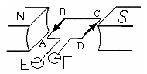
side AB is turning into page initially
coil sides are 2.0 cm,
coil turns at 100 rev/s
coil has 250 turns
B = 0.5 T

- If the coil turns 360⁰, draw the following graphs:
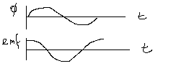
- Δφ Vs time

- emf Vs time

- What is the direction of the current in the first quarter of a turn. B → A

- Which ring (E or F) is positive in the first quarter of the turn. Explain. Electrons moving to E so F must be positive
- Find the average induced emf.

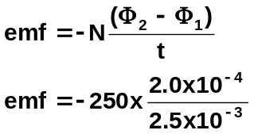100 rev = 1 s
0.25 rev = t
t = 0.25 / 100
= 2.5 x 10⁻³ s

φ = 0.5 x 0.02 x 0.02
= 2 x 10⁻⁴ Wb emf = -20 V

Magnetic Field Strength Revisited in terms of emf
- Magnetic field, B, unit tesla, T
- Magnetic field from permanent magnet or electromagnets.
- Given value for B is field strength at that point that causes force to occur
- Field effect for magnets can induce an emf
  - magnets can move into or out of coil
  - coil can move towards or away from magnet
  - area of coil perpendicular to field can change by turning coil
  - coil shape can change so changing induced emf

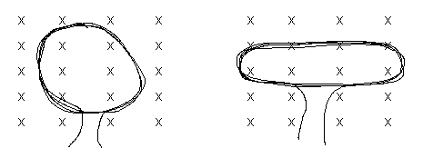
NOTE:
emf = -N (φ₂ - φ₁)
t
Both loops are the same length but the one pulled outwards has less area cut by field so less induced emf as φ = BA
- If using an electromagnet to induce emf in coil, as current through electromagnet can be
changed
  - more rapid field changes induce greater emf
  - emf proportional to rate of change of magnetic flux, φ

Induced Emf revisited

- Can be increased by
  - increasing movement between conductor (coil) and magnetic field.
  - increase length of conductor in field (more coils)
  - increase strength of magnetic field, B
- emf always induced so as to oppose the magnetic field that created it
- Generators induce an emf which then produces current (covered in next section)
- Maximum emf induced when maximum force possible i.e. when coil is parallel to magnetic field
- Minimum emf induced when minimum force possible i.e. when is perpendicular to field
- Diagram below shows coil turning from maximum emf to minimum emf in ¼ turn.

Coil at parallel to Coil at 45⁰ to Coil perpendicular to
field - emf maximum field emf half max value field - emf zero
as maximum force as force = F cos 45 as force on coil zero
(note: minimum area of (note: maximum area of coil
coil to field so magnetic to field so magnetic flux is
flux is zero) maximum value)

- This now explain the graph of emf versus time.
For a coil starting as shown and rotating clockwise 360⁰
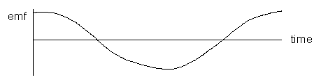
Note:
Compare graphs of emf VS time to magnetic flux VS time, note that graphs are opposite.

Outcomes 11:
Explain and apply the principle of the transformer—this will include applying the relationship: 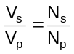

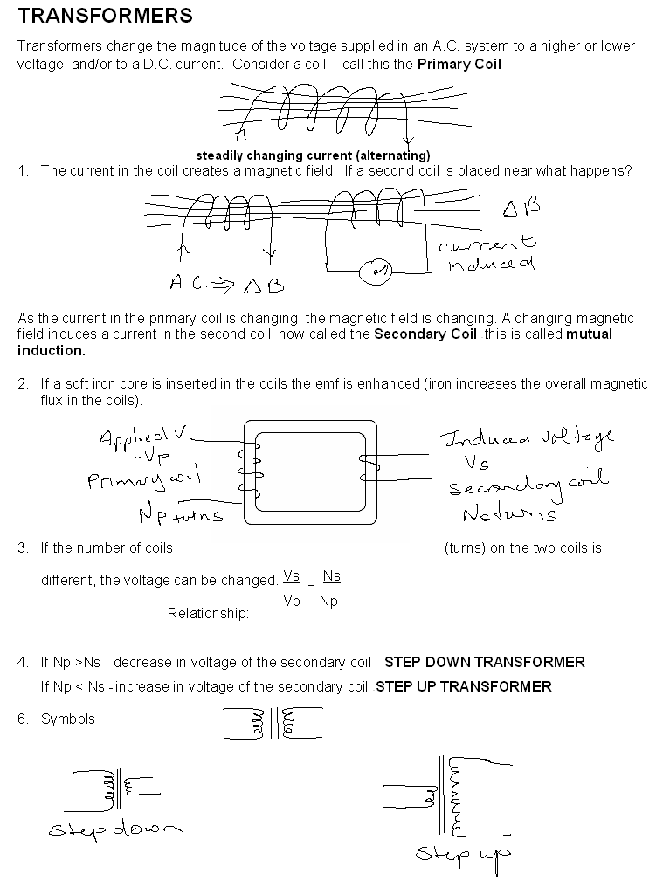

Exploring Physics
Experiment 8.1: Transformers page 89
Experiment 8.2: Voltage and Turns Ratio for a Transformer page 90
Experiment 8.3: Measuring electric energy page 91
Investigation 8.4: Back-emf of an electric motor page 95
Investigation 8.5 to 8.7 are research topics. Your teacher may give you one of these to do.

Outcome 10:
Explain using electric fields the connection between electrical work, charge and potential difference—this will include applying the relationships of electrical work and power: 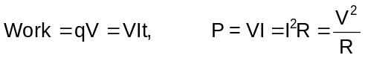

ELECTRIC FIELDS
http://qbx6.ltu.edu/s_schneider/physlets/main/efield.shtml
(Shows different fields both with a positive and negative charge)

An electric field is defined as an area of influence around a charged object. We use field lines as a means of providing a picture of an electric field; however these lines do not actually exist. Line density indicates the strength of the field and is proportional to the charge magnitude.

Your teacher will illustrate the following fields:
a. Field around a point charge where the point is (i) positive, and (ii) negative.
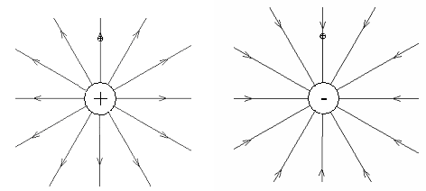

b. Field between two point charges, (i) like charges and (ii) unlike charges.
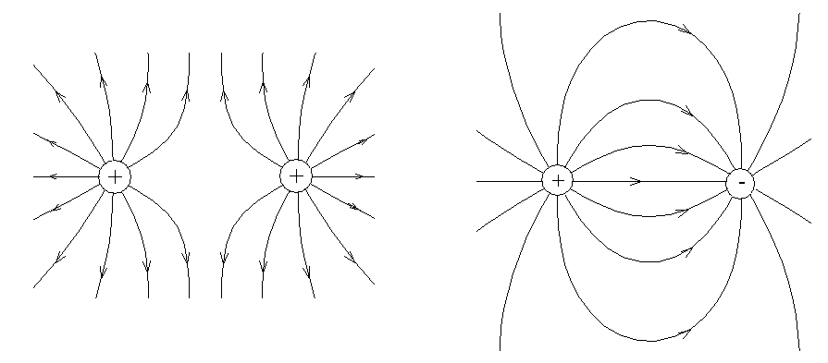

c. Field between two plates, one positive and one negative.
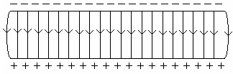

d. Field between a plate and a sphere where (i) both the same charge and (ii) different charges.
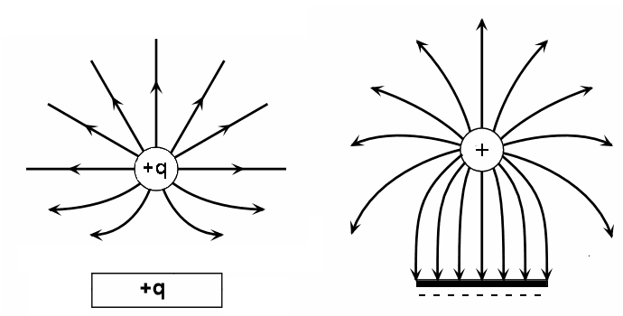

The Coulomb and Electric Charge
The unit of charge is called the coulomb (C). It is customary to define the coulomb (C) in terms of the ampere - the unit of electric current. Along with the kilogram, meter, and second, the ampere is to be considered the fourth fundamental unit, all other electrical units are derived units.

1 coulomb = 1 ampere second.
q = charge in coulombs (C)
I = current in amperes (A)
t = time in seconds (s)
Mathematically, we can express this as 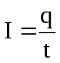 where

More commonly: q = It
Example:
A microwave is used for 1.5 minutes to cook some food. If it uses 450 C of charge, what current does it draw?

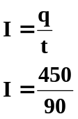t = 1.5 x 60
= 90 s

I = 5.0 A (2 sf)

Example:
A hairdryer needing a current of 6.00 A is used for 10.0 minutes, what charge flowed through the hairdryer during this time?

t = 10 x 60 q = It
= 600 s = 6.00 x 600
= 3600 C

q = 3.60 x 10³ C (3 sf)

Potential Difference and Power
When two points exist at a different potential and are connected, then electrons flow and we have an electric current. Electrical potential difference is measured in terms of the amount of work (energy) that has to be done to move a charge from one place to the other. The unit of electrical potential difference is the VOLT (V).

If in moving a charge of one coulomb from one place to another, one joule of work is done (or 1 joule of kinetic energy is gained), then the electrical potential energy difference between the two places is one volt. Hence,
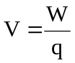 where V = Potential energy in volts (V)
W = work done in joules (J)
q = charge in coulombs (C)
If you re-arrange the formula you get:
W = Vq,
but q = It,
therefore W = Vq = VIt

Hence it can be seen that there is a relationship between work (energy), charge and potential difference.

Examples:
1. A 12V battery supplies 10.0 μC of charge to a toy car. What work is done in moving the charge?

W = Vq
= 12 x 10 x 10⁻⁶
W = 1.2 x 10⁻⁴ J

2. A current of 10.0 mA flows across a potential difference of 2.00 x 10² V for 3.00 minutes. What work is done?

W = VIT
= 200 x (10 x 10⁻³) x (3 x 60)
W = 360 J

Electrical Power
Power is the rate at which energy (work) is produced or used, therefore power is equal to the work done divided by the time taken. The unit for power is the watt (W).

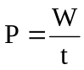 but we also know that work, W = Vq
therefore we can say that 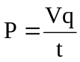
now current is described as the rate of flow of charge or
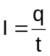
therefore P = Vq = VI where V = potential difference (V)
OR P = VI P = power (W)
I = current (A)

Using Ohm’s Law, V = IR, two other formulas for power can be derived:
P = I²R and 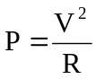
NOTE: These last two formulas will not be given to you in your data sheet.

Electrical Energy Used
The energy consumed by an electrical appliance depends upon the rate of energy use (power rating) and the time for which it is operating. Knowing that work is equivalent to energy,

W = Pt or E = Pt
but P = VI so substituting for P,
E = VIt where E = energy used (or work done) in joules (J)
V = potential difference supplied (V)
I = current (A)
t = operating time (s)

Questions:
  - A motor car’s two headlights are each rated at 50.0 W and operate on a 12.0V power supply.
Calculate the following:
- The current flowing in each headlight when they are in use.
P = VI so 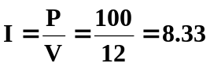

Total current = 8.33 so I for each headlight = 4.17 A

- The charge passing through each globe every second.

q = It
= 4.17 x 1
q = 4.17 C

- The total energy consumed by the two headlights during a 2.00 hour night journey.

E = W = VI_{T}t
= 12 x 8.33 x (2 x 60 x 60)
E = 7.20 x 10⁵ J

  - What is the current drawn by a 2.50 x 10³ W electric kettle if is operates on a 240 V supply?

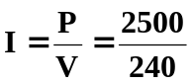
I = 10.4 A

  - If the kettle in question 2 is used for 2.80 minutes, how much electrical energy will it use?

W = VIt
= 240 x 10.4 x (2.8 x 60)
= 419 328
W = E = 4.19 x 10⁵ J

  - A heating appliance is rated at 2.40 kW with a current of 10.0 A. Determine
- the PD across the appliance,

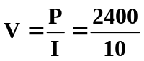= 240 V

- amount of heat converted from electrical energy,

W = VIt = 240 x 10 x 60
W = 1.44 x 10⁵ J

- the total charge flowing through it per minute.

q = It = 10 x 60
q = 600 C

Outcomes 12:
Explain why electrical energy is transmitted as ac at very high voltages, and describe and explain the impact on everyday life of electrical power generation and transmission—this will include applying the relationships: 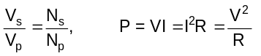.

POWER ACROSS THE COUNTRY

Electric Power System
Electricity is generated when a loop of conducting wire rotates in a magnetic field. In a hydroelectric plant, water falling over a dam turns turbines that spin the generators that produce electricity. The electricity flows to a transmission station where a transformer changes a large current and low voltage into a small current and high voltage. Then the electricity flows over high voltage transmission lines to a series of transmission stations where the voltage is stepped down by transformers to levels appropriate for distribution to customers. Primary lines may transmit electricity at voltages as high as 500,000 volts. Secondary lines to homes carry electricity at 240 V.

See diagram page 79 of WACE Study Guide.

POWER TRANSMITION

Power stations produce large currents, as much as 20 000 A. This requires very thick and expensive cable to carry it about the country. We know that P = VI. We don’t want the power to change, however if we increase the voltage we can decrease the current. A smaller current can be carried on thinner, lighter cables reducing cost. Transformers are used to change the magnitude of the voltage.

Power lost as heat is equal to P = I²R. The resistance remains unchanged so if we decrease the current, say by 10, this will result in a decrease in power loss of 100. An equally important reason to use a high voltage.

Example:
8.00 kW of power is produced by an AC generator and this is transmitted at 240 V down a line which is 5.0 km long. If the wire has a resistance of 0.40 Ω m⁻¹ , calculate:
a. the power lost in the line.
b. the voltage which reaches the end of the line

a. P = 8 x 10⁴ W 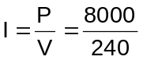
V = 240 V I = 33.333 A
R_{T} = 5 x 0.4
= 2.0 Ω Power lost, P = I²R
= 33.333² x 2
P = 2222 W
Power lost = 2.22 x 10³ W

b. voltage lost along line = IR
= 33.33 x 2
= 66.66 V

voltage at end = 240 – 66.66 OR P _{end} = V _{end} x I
= 173 V (8000 – 2222) = V x 33.33
V = 173
Exploring Physics:
Set 8: Electrical Energy and Power page 92
REVISION ELECTRIC POWER.

- Why should you not place a cassette tape near electrical cords?

- A beam of electrons is travelling at 5.00 x 10⁶ ms⁻¹ and is moving from left to right into a magnetic field that is directed vertically upwards. Find the magnitude and direction of the force acting on each electron if the field has an intensity of 8.00 x 10⁻⁵ T

- What is the radius of curvature of the path of the electron in question 2?

- Imagine you are driving a truck at 90.0 kmh⁻¹ in a region where the vertical component of the earth’s magnetic field is 4.0 x 10⁻⁵ T. If an axle of the truck is 1.52 m long, calculate the emf generated across it.

- Find the emf generated in the wings of an aircraft travelling horizontally at 597 ms⁻¹ if the wing span is 25.0 m and the vertical component of the earth’s magnetic field has a flux density of 5.00 x 10⁻⁵ T?

- A coil of 1 000 turns is threaded by a flux of 0.85 Wb. If the flux is then reduced to 0.15 Wb in 2.5 ms, what is the average emf induced in the coil?

- A coil in a small motor has 100 turns. The shape of the coil is 10 cm long by 4 cm wide. It carries a current of 5 A when the field strength is 0.08 T. Calculate the torque on the coil.

- A ticker timer is a device used to produce regular vibrations of a striker on a tape to measure the velocity and/or acceleration of the tape.
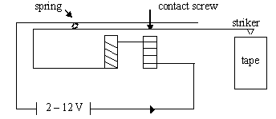

- When the power is momentarily switched on, the striker will hit the tape, explain why.
- Once the power remains on the striker will vibrate. Explain why
- How could the devise be changed to make the striker hit harder?
- Why are the coils wound in opposite directions?
- Look at the following simple motor.

- If the coil is parallel, when switched on, which way will the side AB move?
- Why does the coil rotate when the current is switched on?
- How would you make the coil turn faster?

- When two conductors next to each other have currents running in opposite directions,
- what would happen to the conductors?
- draw the fields.

- Find the emf generated in the wings of an aircraft travelling horizontally at 5.97 x 10² ms⁻¹ if the wings span is 25.0 m and the vertical component of the earth’s magnetic field has a flux density of 5.00 x 10⁻⁵ T.

- The rate of blood-flow can be measured by the apparatus below since blood contains charged ions.
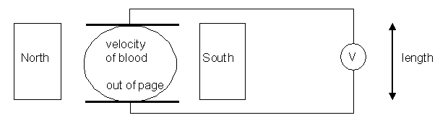
Suppose that the blood vessel is 2.0 mm in diameter, the magnetic field is 0.08 T, and the
measured emf is 0.1 mV. What is the flow velocity of the blood?

- You set up a solenoid attached to a sensitive galvanometer (measures very small changes in current) to investigate Lenz’s law. For each of the following situations, say whether the current will flow through the galvanometer in direction A or B (if no current, say ‘no current’).
a.
S N

magnet moving into coil A B
A

b.
N S

magnet moving away from coil A B

c. S N
ACME
Electromagnet
A B
Power supply
on Electromagnet turned on and up to strength

d. S N
ACME
Electromagnet
A B
Power supply
on
Electromagnet left at high strength for 60 s.
e. S N
ACME
Electromagnet
A B
Power supply
off
Electromagnet switched off

FINAL REVISION:

Complete all the questions in your WACE study guide.

